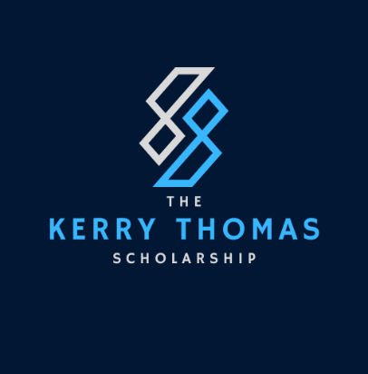

***The Kerry Thomas Scholarship Award***

On Wednesday 3 November 2021, Kerryann Thomas passed away suddenly while preparing for work that day. Her 12 year old daughter observed her mother experiencing difficulties and dialled for an Ambulance however despite emergency assistance, Kerry was unable to be revived.

Kerry joined Corrective Services NSW on 30 May 2003 as a temporary Admin Officer at Windsor Community Corrections and was appointed in 2006 as an Intensive Supervision Support Officer until 2007 when she commenced in her role and a Probation and Parole Officer in Parramatta in 2008. Working in various city locations she moved to Grafton Community Corrections as a Unit Leader in 2020 until the day of her passing.

Kerry was a much loved and respected leader in her role within Community Corrections. She valued those with whom she worked, both staff and clients alike. She fostered an immense amount of pride for her work, her bubbly personality and heart felt encouragement for those around her always being her ‘vibe’ wherever she went. On the day of her passing Kerry was to be awarded a District Recognition Award *for ‘Excellent Leadership & taking pride in developing a positive culture’.*

Kerry became an Executive member of PPOANSW in 2016 and subsequently in 2018 became the NSW Delegate and Executive Secretary in the Probation and Community Correction Officer’s Association (PACCOA), her passion for professional development and networking being fulfilled in this role. This undertaking was seen as the pinnacle of her volunteer career pathway and was a significant responsibility taken on with her quirky enthusiasm and verve. Kerry was an amazing asset to the Executive Team between 2018 and 2021, second to none, and she is sorely missed given her sudden passing.

Kerry always rose to the occasion, having shaped pathways for others in pursuit of professional development opportunities and her affection for her family, her work and her colleagues was contagious. As Former President of PACCOA, I had the privilege to work alongside her in our roles, as she was a champion for everything about learning, leading the way, sharing story and her love of people. She was an advocate for seeing people Be and Do better, having lived the hard yards experience herself.

It is with great sadness and extreme pleasure that PACCOA/PPOANSW honour Kerry’s memory with the naming rights for the new Kerrann Thomas Education Scholarship Award, in honour of her memory, which will carry with it pride, passion and love for personal and professional education, an ethos which PACCOA and PPOANSW are partnering and investing in for 2022.